Techno Machine Tools
Survey no:126/A/1, DOOR NO: 4-132-9/A/2, Gandimaisamma X Road,
Medchal Malkajgeri,Hyderabad-500043.Telangana, India.

(MANUFACTURERS OF ROLL FORMING MACHINES)

T.SIVARAMAKRISHNA
ME., MBA.
--------------------------------------------------------------------------------------------------------------------------------------

Ref:- TM/Mahamood/S0284/2025 22-.05-2025

To,
Mahamood Muhammad

star, Hyderabad - 500003, Telangana, India
Email: mahmood924m@gmail.com
Mobile: +(91)-9640590302

Dear sir,

Sub: - SUPPLY OF ROLL FORMING MACHINE - WITH 60x60 L Angle Tooling

Thank you very much for your enquiry regarding your requirement of roll forming machine mainly for 60x60 L Section. We are glad to inform you that we would be in a position to supply you the required equipment. Given below are the required specifications and description of the machine and our terms and conditions.

Prices

The cost of Roll forming machine with tooling for 60x60 Angle section along with de coiler, Entry guide, cutting press and cutting tool, delivery stopper along with drive system and Electrical panel RS 12,50,000=00 ( Rupees Twelve Lakhs Fifty Thousand Only)

LIST OT EQUIPMENT

- ROLL FORMING MACHINE WITH 9 PASSES
- EN 31 MATERIAL TOOLING
- 5 HP DRIVE
- COMPLETE ELECTRICALS
- Panel with plc

Technical specifications:

MAIN ROLL FORMING MILL

Maximum sheet width that can be formed : 220 MM

Maximum sheet thickness in MS that can be formed : 6 MM

Minimum sheet thickness in MS that can be formed : 1.2 MM

Roll shaft diameter : dia 60 MM

The vertical distance between shafts : 230 MM

The horizontal distance between shafts : 250 MM

Number of forming stations : 7 Nos

Drive (DC) : 15 HP

Speed of the machine : 12 meters/max

Description of the equipment

Roll Forming Machine

Main Base

The main base is MS fabricated structure and adequately ribbed to minimize the distortion. It is accurately machined on top and bottom surfaces the threaded holes are made on the bed for positioning the stands.

Entry Guide

The entry side of the machine will be equipped with guide table and the guide wheels bar which will be responsible for centering the leading ends of the strip into the first pass.

Roll shafts

The roll shafts will be manufactured from quality steel and will be keyed to locate tooling.

Drive

The drive to the roll former will be by means of a gear box system. The main drive will be provided by means of 15 HP motor. The speed of the roll former is fixed.

Delivery run out table

The delivery runout table is with four meters length.

GENERAL TERMS & CONDITIONS:

- Price quoted per unit ex-work. Hyderabad.
- Following charges are additional to your account.
- Freight Charge : As actual to be borne by you.
- Excise : Extra As Applicable
- Sales Tax : Extra as applicable
- Packing charge : As actual to be borne by you.
- Insurance : As actual to be borne by you.
- Payment : 60% advance along with order balance before delivery but after inspection at our works.
- Delivery : Within 3 months from date of advance received
- Validity : One month from the date of submission.
- Inspection : Inspection at our works prior to dispatch.
- Warranty : The machine is warranted for a period of 12 months from the date of dispatch against any manufacturing defects/ faulty material or bad workmanship of any part or component but not against any kind of abnormal or improper use of machine. Defective part or component will be replaced or repaired free of cost. Electrical components are outside the scope of this warranty.
- Commissioning : Erection & commissioning done by you, but required technical support & guidance provide by us at additional cost.

NOTE:
- Oil is not in scope of our supply.
- Raw material for trial is to be arranged by you at your cost.

We are sure you will find our offer in line with your requirements. Should you require any further clarification please contact t.sivaramakrishna 9246221106.
Email : srktalam@gmail.com

Thanking you and assuring you of our best services.

For TECHNO MACHINE TOOLS

(T.SIVARAMAKRISHNA)

TECHNO MACHINE TOOLS
Survey no:126/A/1, DOOR NO: 4-132-9/A/2, Gandimaisamma X Road,
Medchal Malkajgeri,Hyderabad-500043.Telangana, India.

T.SIVARAMAKRISHNA
ME., MBA.

Ref:- TM/Mahamood/S0284/2025 22-.05-2025

To,
Mahamood Muhammad

star, Hyderabad - 500003, Telangana, India
Email: mahmood924m@gmail.com
Mobile: +(91)-9640590302

Dear sir,

Sub :- Supply of 3 ROLLER Horizontal 2 inch pipe roll bending machine.

We are very much thankful to you for your enquiry regarding above bending machine. As requested by you we are submitting hereunder the detailed specifications

PRICE

1. Three roller horizontal bending machine for bending 2 Inch angle and thickness maximum 6 mm with 5 hp drive gear box and gear system is RS 2,45,000=00
( Rupees Two Lakh Forty Five Thousand Only)

GENERAL TERMS & CONDITIONS:

- Price quoted per unit ex-work. Hyderabad.
- Following charges are additional to your account.
- Freight Charge : As actual to be borne by you.
- Excise : 10.30%
- Sales Tax : 5% Vat.
- Packing charge : As actual to be borne by you.
- Insurance : As actual to be borne by you.
- Payment : 50% advance alongwith order
balance before delivery but after inspection at our
works.
- Delivery : within 20 days from the date of advance.
- Validity : One month from the date of submission.
- Inspection : Inspection at our works prior to dispatch.
- Warranty : The machine is warranted for a period of 12
months from the date of dispatch against any
manufacturing defects/faulty material or bad
workmanship of any part or component but not
against any kind of abnormal or improper use of
machine. Defective part or component will be
replaced or repaired free of cost. Electrical
components are outside the scope of this
warranty.
- Commissioning : Erection & commissioning done by you, but if
required technical support & guidance provide by
us at additional cost.
NOTE:

- Oil is not in scope of our supply.
- Raw material for trial is arranged by you at your cost.
We are sure you will find our offer in line with your requirements. Should you require any further clarification please call us on mobile number 9246221106.email: srktalam@gmail.com

Thanking you and assuring you of our best services.

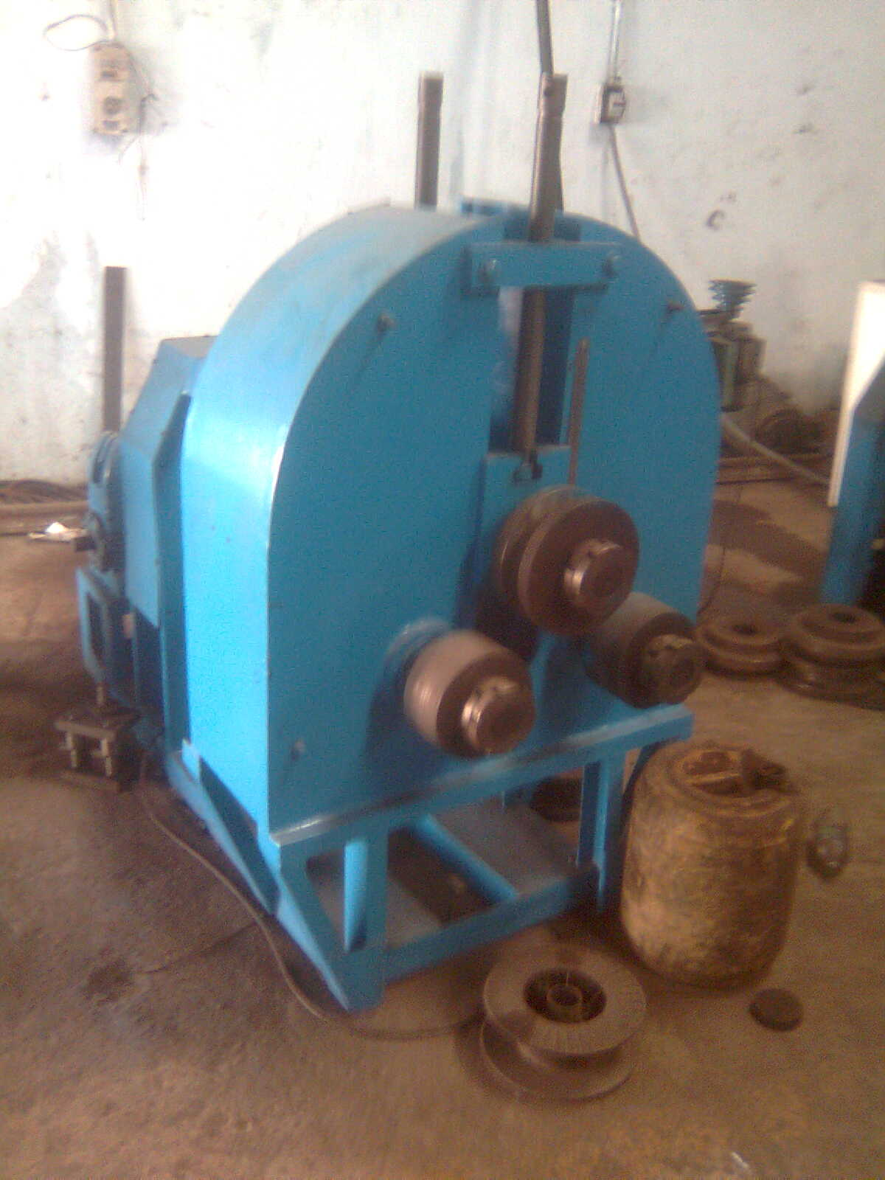

For TECHNO MACHINE TOOLS

( T. SIVARAMAKRISHNA)

